Euclid’s Postulates: Geometry on a plane or in space i.e., Euclidian Geometry focuses on points, lines, angles, planes (triangle, square, circle etc.) and some solids.
  - A straight line segment can be drawn joining any two points.
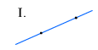
  - Any straight line segment can be extended indefinitely in a straight line.
  - Given any straight lines segment, a circle can be drawn having the segment as radius and one endpoint as center.
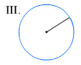
  - All Right Angles are congruent.
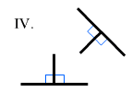
  - If two lines are drawn which intersect a third in such a way that the sum of the inner angles on one side is less than two Right Angles, then the two lines inevitably must intersect each other on that side if extended far enough. This postulate is equivalent to what is known as the Parallel Postulate.
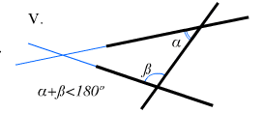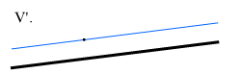

In plane Euclidian Geometry, a plane is a flat surface made up of points that extend infinitely in all directions.
In Spherical Geometry, or Geometry on a sphere, a plane is the surface of a sphere.
A non-Euclidian geometry is a geometry in which at least one of the postulates from Euclidian geometry fails. For instance, the Parallel Postulate does not hold true on a sphere since lines, or great circles, cannot be parallel in spherical geometry, thus, Spherical Geometry is non-Euclidian.

