Chapter 1 Tools of Geometry
Lesson 1.1. Notes – Points, Lines and Planes
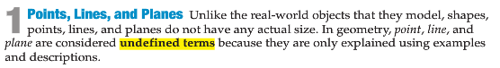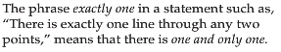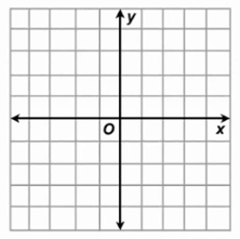
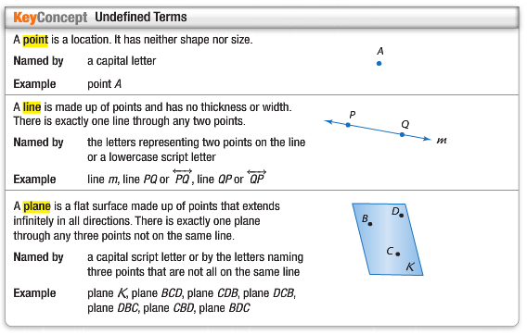
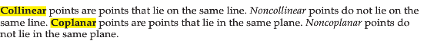
Name Lines and Planes
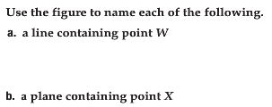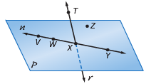
1)
c. a line containing point T. d. a plane containing points T and Z.

2) Use the figure below and answer the following questions.
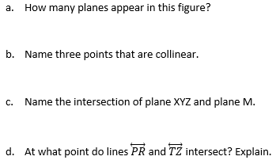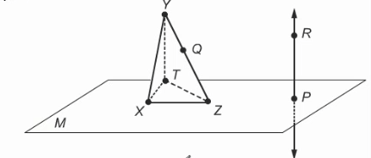

Model Points, Lines, and Planes
1) Name the geometric shapes modeled by the picture.
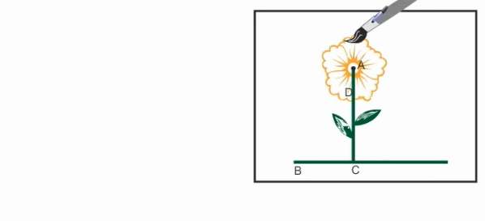
2) Name the geometric term modeled by each object.
a.stripes on a sweater. b.corner of a box c.cover of a book
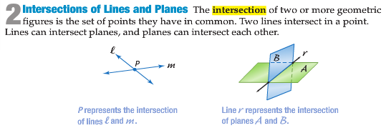

Draw Geometric Figures
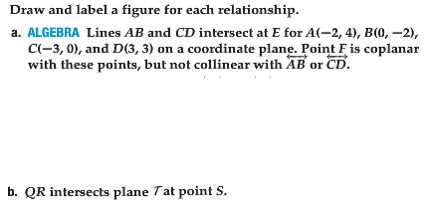
3)

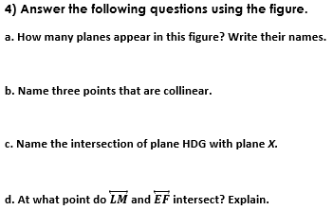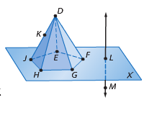

Describing What You See
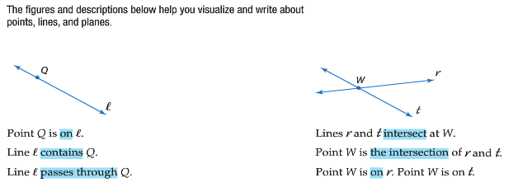
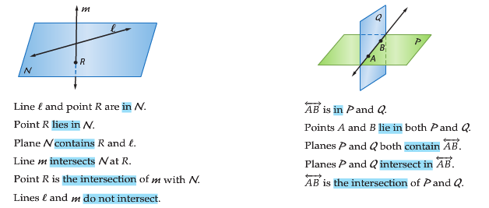
Homework: Write a description for each figure for questions 1-3 and answer 4 (just as the examples on this page.)
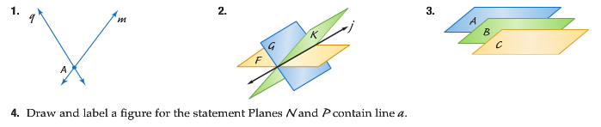

ANSWER ALL 4 QUESTIONS IN YOUR GEOMETRY NOTEBOOK! NO WORK = 0 GRADE!!!
KEEP THIS NOTES IN YOUR BINDER. IF YOU LOOSE IT = 0 GRADE!!!

