Lesson 1.4. Notes Angle Measures
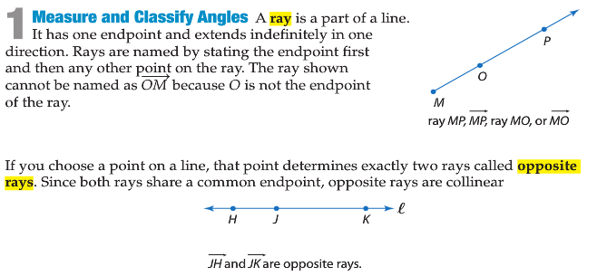
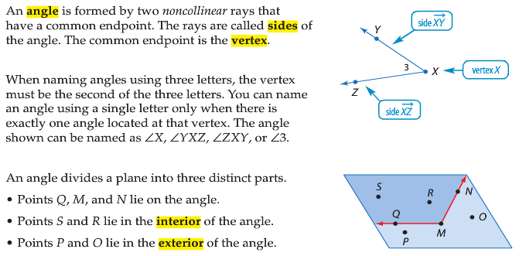
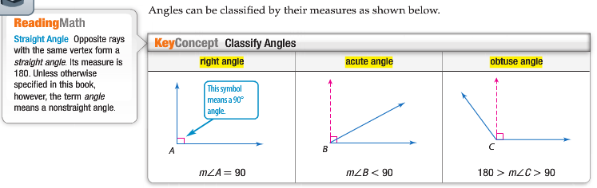
Angles and Their Parts
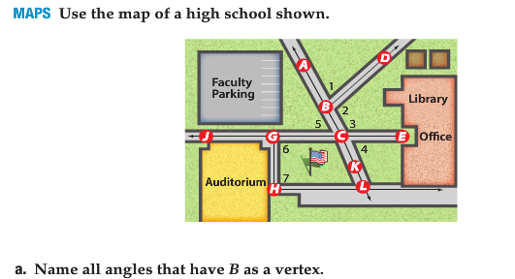

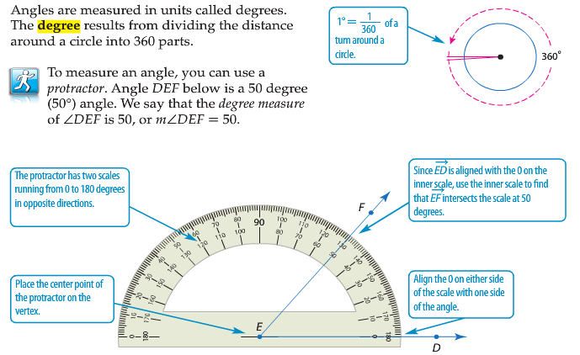

Measure and Classify Angles
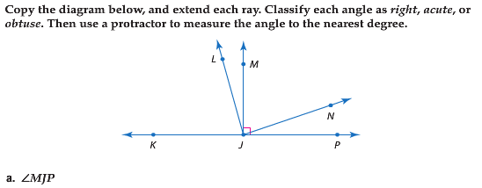

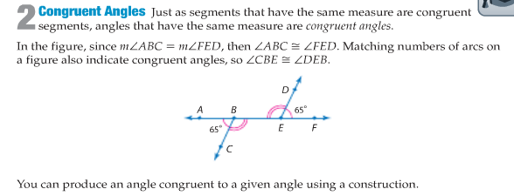
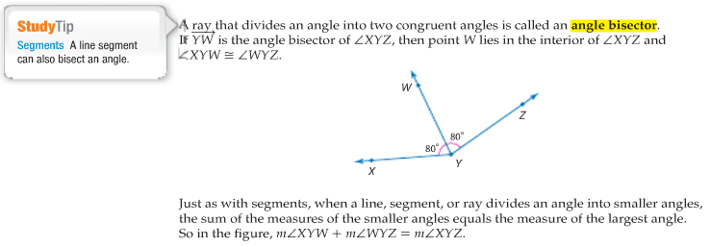
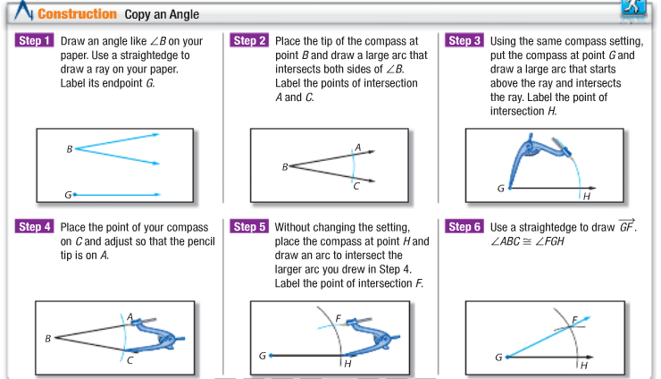
Follow all the steps above and draw angle FGH which has same measure with angle B below.

ANSWER ALL 4 QUESTIONS IN YOUR GEOMETRY NOTEBOOK! NO WORK = 0 GRADE!!!
KEEP THIS NOTES IN YOUR BINDER. IF YOU LOOSE IT = 0 GRADE!!!

