Lesson 1.6. Notes Two-Dimensional Figures
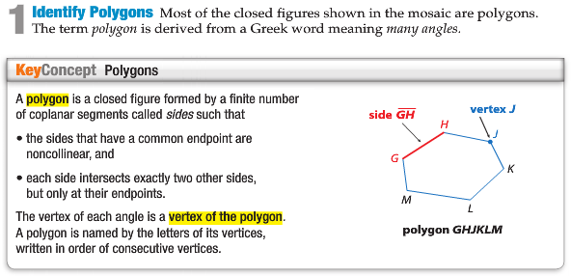
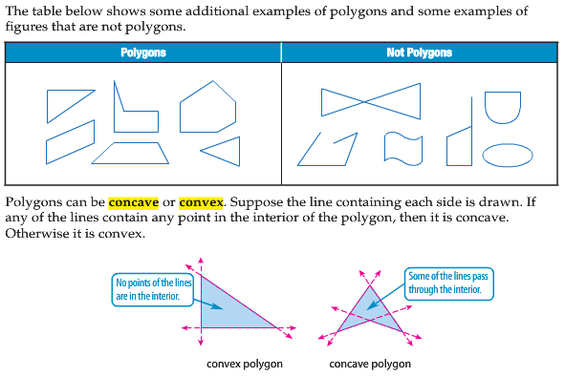
Name and Classify Polygons:
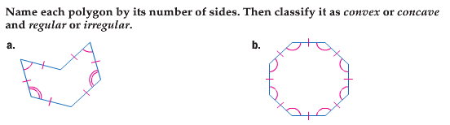

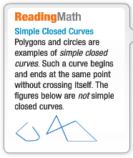
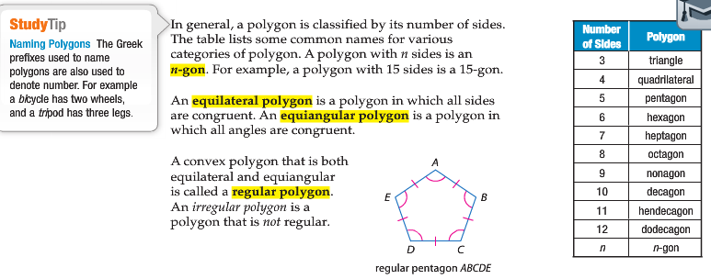

Name and Classify Polygons:
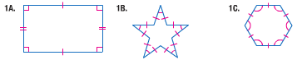

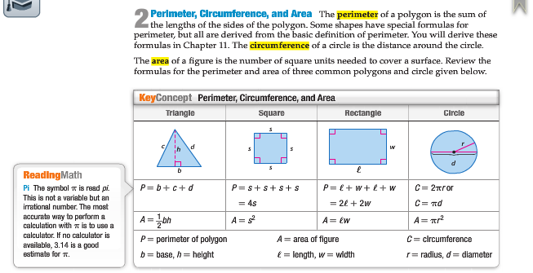
Find Perimeter and Area:
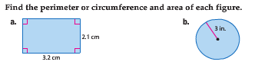
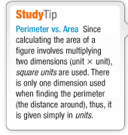
Perimeter and Area on the Coordinate Plane:
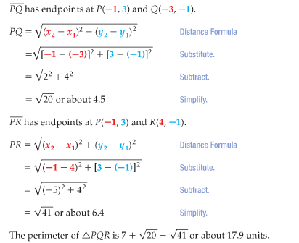
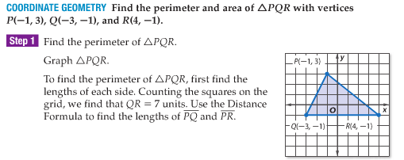

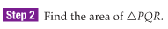
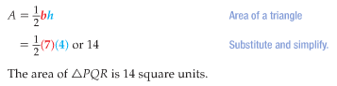
COMPLETE ALL PARTS AND KEEP IT IN YOUR BINDER! IF YOU LOOSE IT = 0 GRADE!!!

