Chapter 2 Reasoning and Proof
Lesson 2.1 Notes Inductive Reasoning and Conjecture
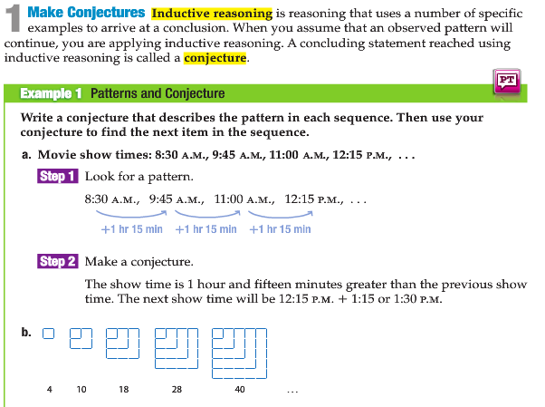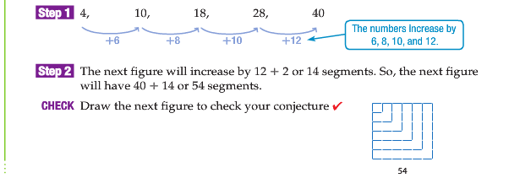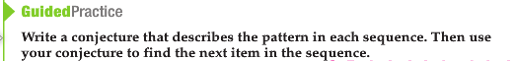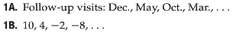
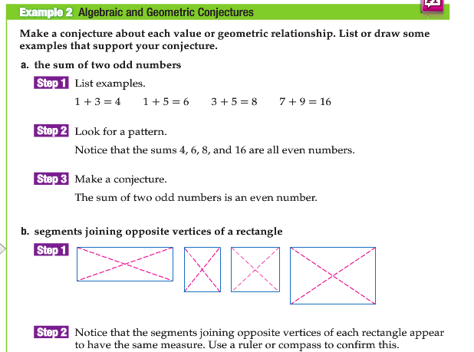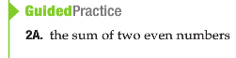

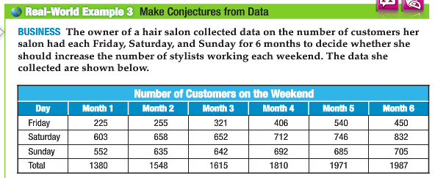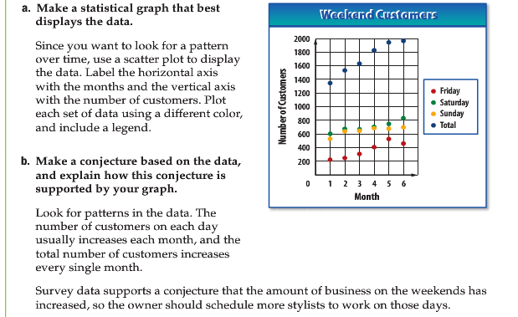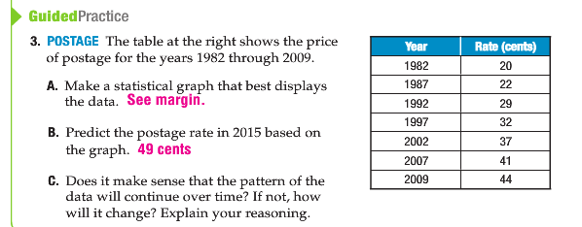

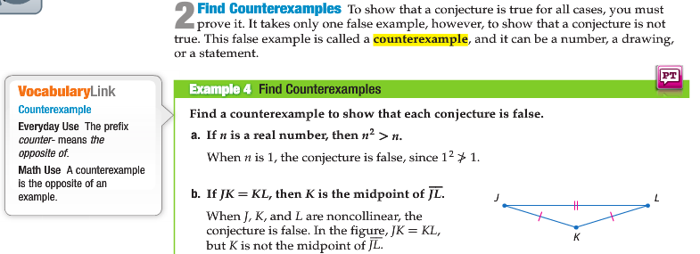

Homework: Complete all questions on this sheet by 9/29 beginning of the lesson
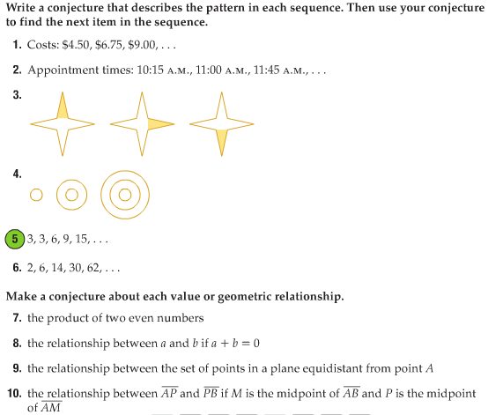

READ ALL PARTS AND WRITE DOWN THE VOCABULARY in YOUR NOTEBOOK! COMPLETE ALL PRACTICE QUESTIONS! KEEP IT IN YOUR BINDER! IF YOU LOOSE IT = 0 GRADE!!!

