Chapter 4 Congruent Triangles
Lesson 4.1 Classifying Triangles - Notes and Practice
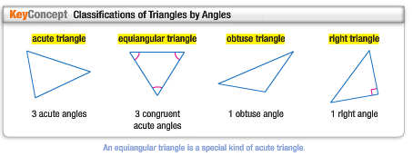
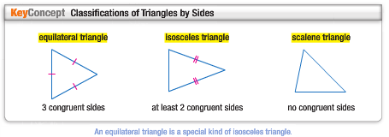
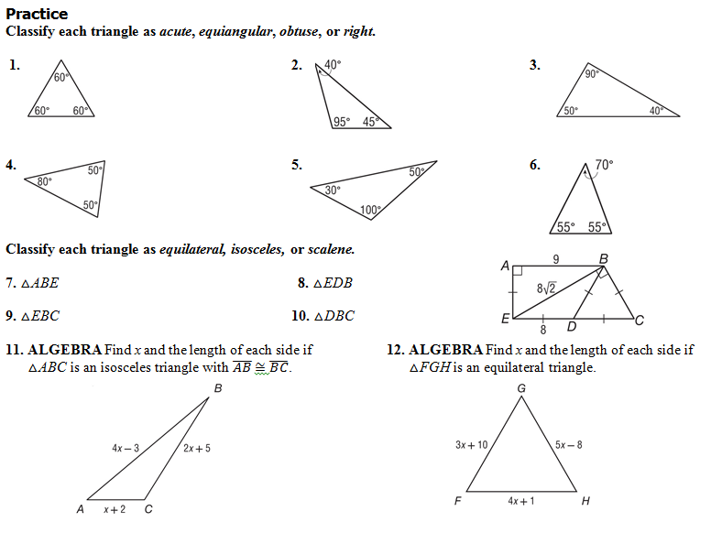

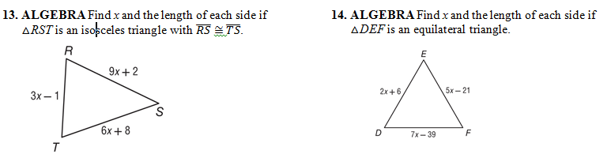

Word Problems
1. MUSEUMS Paul is standing in front of a museum exhibition. When he turns his head 60° to the left, he can see a statue by Donatello. When he turns his head 60° to the right, he can see a statue by Della Robbia. The two statues and Paul form the vertices of a triangle. Classify this triangle as acute, right, or obtuse.

2. PAPER Marsha cuts a rectangular piece of paper in half along a diagonal. The result is two triangles. Classify these triangles as acute, right, or obtuse.
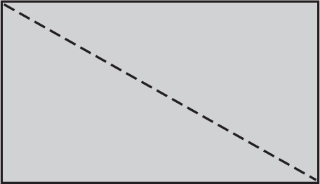

3. WATERSKIING Kim and Cassandra are waterskiing. They are holding on to ropes that are the same length and tied to the same point on the back of a speed boat. The boat is going full speed ahead and the ropes are fully taut.
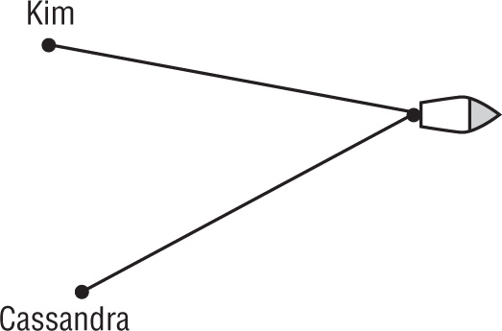

Kim, Cassandra, and the point where the ropes are tied on the boat form the vertices of a triangle. The distance between Kim and Cassandra is never equal to the length of the ropes. Classify the triangle as equilateral, isosceles, or scalene.

4. BOOKENDS Two bookends are shaped like right triangles.
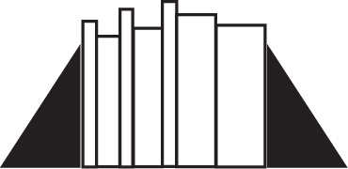

The bottom side of each triangle is exactly half as long as the slanted side of the triangle. If all the books between the bookends are removed and they are pushed together, they will form a single triangle. Classify the triangle that can be formed as equilateral, isosceles, or scalene.

5. DESIGNS Suzanne saw this pattern on a pentagonal floor tile. She noticed many different kinds of triangles were created by the lines on the tile.
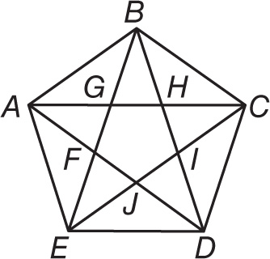

a. Identify five triangles that appear to be acute isosceles triangles.

b. Identify five triangles that appear to be obtuse isosceles triangles.
ALL PARTS NEED TO BE COMPLETED! SHOW WORK! NO WORK = 0 GRADE!!! KEEP NOTES IN YOUR BINDER. IF YOU LOOSE IT = 0 GRADE!!!

