Chapter 4 Congruent Triangles
Lesson 4.2 Angles of Triangles - Notes and Practice
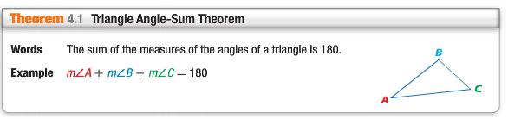
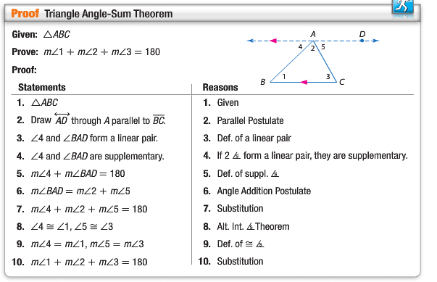
Real-World Example:
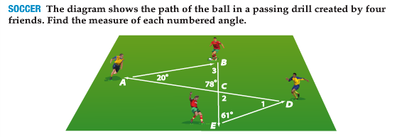

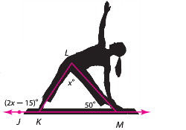
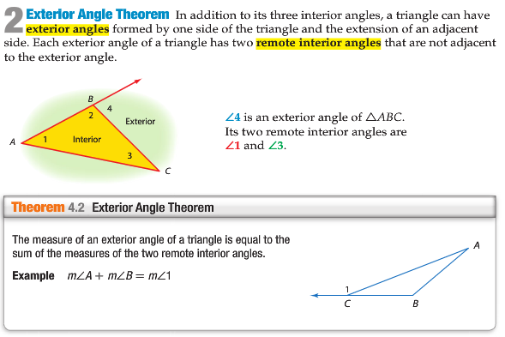
Example:

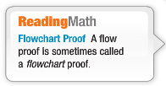
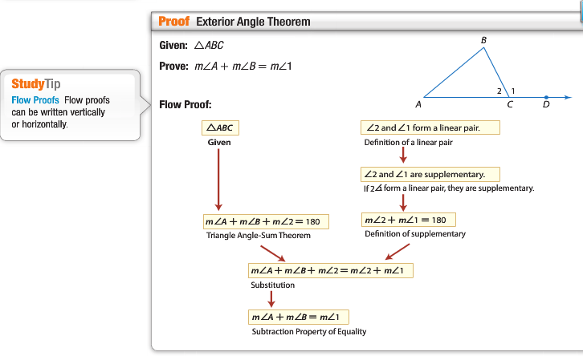
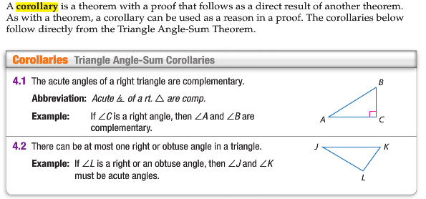
Practice
Find the measure of each numbered angle.

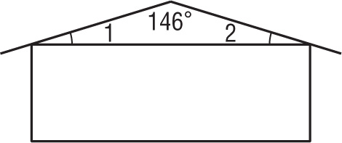
1. 2.

Find each measure.
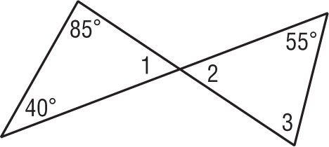
3. m∠1

4. m∠2

5. m∠3
Find each measure.
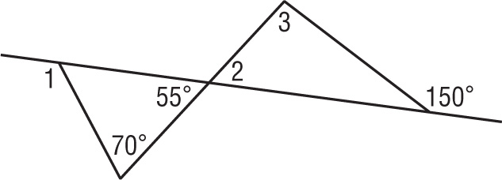
6. m∠1

7. m∠2

8. m∠3
Find each measure.
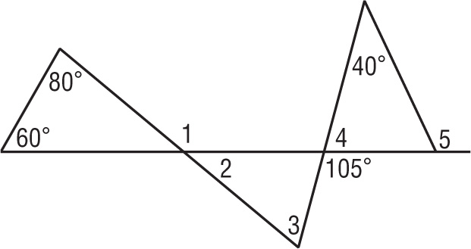
9. m∠1

10. m∠2

11. m∠3

12. m∠4

13. m∠5
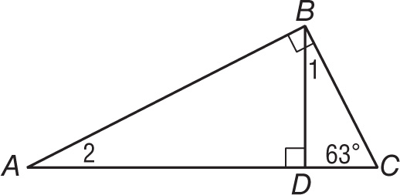
Find each measure.
14. m∠1

15. m∠2

ALL PARTS NEED TO BE COMPLETED! SHOW WORK! NO WORK = 0 GRADE!!! KEEP NOTES IN YOUR BINDER. IF YOU LOOSE IT = 0 GRADE!!!

